**PRODUCT SPECIFICATION Version 1.2**

# IEEE 802.11 b/g/n 1T/1R Low-Energy IOT Module Model Number : WL11M1000

**（MT7682SN）**

1. **General Description**

#### This document is to specify the product requirements for 802.11b/g/n 1T1R Module.

It is based on MTK MT7682 low-power chipset that complied with IEEE 802.11n,and it is also backward complied with IEEE 802.11b/g standard from 2.4~2.5GHz. It can be used to provide up to 54Mbps for IEEE 802.11g,11Mbps for IEEE 802.11b and 150Mbps for IEEE 802.11n to connect your wireless LAN.

With seamless roaming, fully interoperability and advanced security with WEP standard, 802.11b/g/n Module offers absolute interoperability with different vendors 802.11g, 802.11b, 802.11n Access Points through the wireless LAN.

1. **Features**

* Supports all data rates of 802.11g including 6, 9, 12, 18, 24, 36, 48 and 54Mbps
* Supports short GI and all data rates of 802.11n including MCS0 to MCS7 .
* Wi-Fi security WEP, WPA2 and WPS. .
* Supports SoftAP and sniffer modes.
* Supports MediaTek Smart Connection.
* Supports multi-cloud connectivity.
* Multiple interfaces are multiplexed with GPIO.
* Light Weight TCP/IP protocol
* RoHS compliant.

1. **Application Diagrams**
   1. Functional Block Diagram

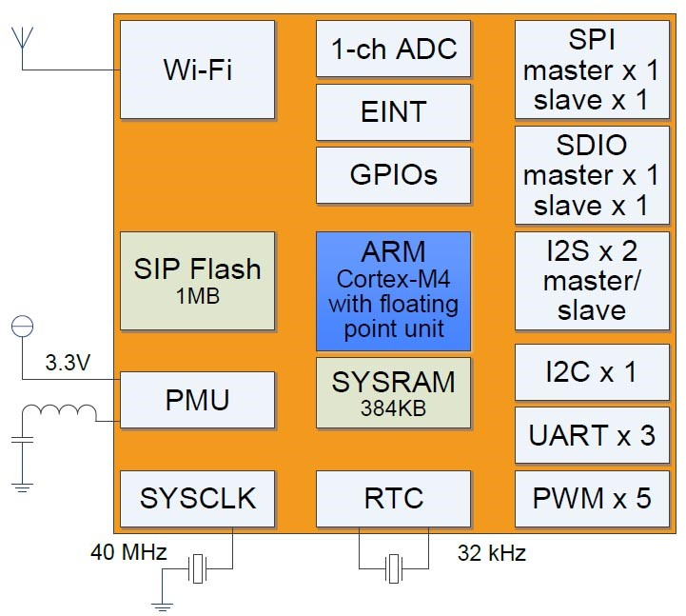

Figure 1

* 1. General Requirements
     1. *IEEE 802.11b Section*

|  |  |  |
| --- | --- | --- |
|  | **Feature** | **Detailed Description** |
| 3.2.1.1 | Standard | * IEEE 802.11b |
| 3.2.1.2 | Radio and  Modulation Schemes | * DQPSK , DBPSK and CCK with DSSS |
| 3.2.1.3 | Operating Frequency | * 2400 ～ 2483.5MHz ISM band |
| 3.2.1.4 | Channel Numbers | * 13 channels for Worldwide |
| 3.2.1.5 | Data Rate | * at most 11Mbps |
| 3.2.1.6 | Media Access Protocol | * CSMA/CA with ACK |
| 3.2.1.7 | Transmitter Output Power at Antenna  Connector | * Typical RF Output Power at each RF chain, and at room Temp. 25℃ * 17±2 dBm at 11Mbps |
| 3.2.1.8 | Receiver Sensitivity  at Antenna Connector | * Typical Sensitivity at each RF chain. @Frame (1000-byte PDUs) Error Rate<8% at room Temp 25℃ * -83 dBm for 11Mbps |

* + 1. *IEEE 802.11g Section*

|  |  |  |
| --- | --- | --- |
|  | **Feature** | **Detailed Description** |
| 3.2.2.1 | Standard | * IEEE 802.11g |
| 3.2.2.2 | Radio and Modulation Type | * QPSK , BPSK , 16QAM ,64QAM with OFDM |
| 3.2.2.3 | Operating Frequency | * 2400 ～ 2483.5MHz ISM band |
| 3.2.2.4 | Channel Numbers | * 13 channels for Worldwide |
| 3.2.2.5 | Data Rate | * at most 54Mbps |
| 3.2.2.6 | Media Access Protocol | * CSMA/CA with ACK |
| 3.2.2.7 | Transmitter Output Power at Antenna Connector | * Typical RF Output Power at each RF chain, at room Temp. 25℃ * 14±2 dBm at 54Mbps |
| 3.2.2.8 | Receiver Sensitivity  at Antenna Connector | * Typical Sensitivity at each RF chain. @Frame (1000-byte PDUs) Error Rate<10% at room Temp 25℃ * -71 dBm for 54Mbps |

* + 1. *IEEE 802.11n Section*

|  |  |  |
| --- | --- | --- |
| 3.2.3.1 | Standard | * IEEE 802.11n |
| 3.2.3.2 | Radio and Modulation Type | * BPSK , QPSK , 16QAM ,64QAM with OFDM |
| 3.2.3.3 | Operating Frequency | * 2400 ～ 2483.5MHz |
| 3.2.3.4 | Data Rate(Mbps) | * at most 150 Mbps |
| 3.2.3.5 | Media Access Protocol | * CSMA/CA with ACK |
| 3.2.3.6 | Transmitter Output Power at Antenna Connector | * Typical RF Output Power at each RF chain, at room Temp. 25℃ HT20 * 12±2dBm at MCS7 HT40 * 12±2dBm at MCS7 |
| 3.2.3.7 | Receiver Sensitivity at Antenna Connector | ● Typical Sensitivity at each RF chain. @Frame(1000-byte PDUs)Error Rate=10% and at room Temp. 25℃  HT20  ● -68dBm at MCS7 HT40  ● -68dBm at MCS7 |

* 1. Memory
* Up to 384KB SRAM, with zero-wait state and 96MHz maximum frequency
* Up to 32KB L1 cache with high hit rate, zero-wait state and 192MHz maximum frequency.
* Embedded 8Mbits flash, with less than 0.1μA (typical) and 80MHz maximum frequency deep power-down current

1. **Electrical and Thermal Characteristics**
   1. Temperature Limit Rating

|  |  |  |  |
| --- | --- | --- | --- |
| Parameter | **Minimum** | **Maximum** | **Units** |
| Storage Temperature | -40 | +80 | ℃ |
| Ambient Operating Temperature | 0 | 60 | ℃ |
| Junction Temperature | 0 | 125 | ℃ |

* 1. General Section

|  |  |  |
| --- | --- | --- |
|  | **Feature** | **Detailed Description** |
| 4.2.1 | Antenna Type | * Pad connect |
| 4.2.2 | Operating Voltage | * 3.3V±10% |
| 4.2.3 | Current Consumption | * ＜120mA@RX * ＜300mA@TX |

* 1. Mechanical Requirements

|  |  |  |
| --- | --- | --- |
|  | **Feature** | **Detailed Description** |
| 4.3.1 | Length | * 12mm |
| 4.3.2 | Width | * 12mm |
| 4.3.3 | Height | * 0.8mm(PCB) |
| 4.3.4 | Weight | * 0.4g |

* 1. Mechanical Dimensions

Dimension error range：

|  |  |
| --- | --- |
| DIM (MM) | Tolerance (MM) |
| 0-5 | ±0.15 |
| 5-10 | ±0.20 |
| 10-50 | ±0.30 |

### Pin Definitions

|  |  |  |  |  |  |
| --- | --- | --- | --- | --- | --- |
| **Pin** | **Symbol** | **Description** | **Pin** | **Symbol** | **Description** |
| 1 | 32K_X1 | Input pin for External 32K crystal | 16 | VCC | 3.3V power input |
| 2 | 32K_X2 | Input pin for External 32K crystal | 17 | n.c | n.c |
| 3 | RTC_EINT | Dedicate EINT input in RTC | 18 | GND | Ground |
| 4 | VRTC | RTC domain power supply | 19 | GND | Ground |
| 5 | EXT_PWR_EN | PMU enable | 20 | RF | RF I/O |
| 6 | CHIP_EN | Chip enable | 21 | GND | Ground |
| 7 | GPIO0 | General purpose input/output | 22 | GND | Ground |
| 8 | GPIO1 | General purpose input/output | 23 | GPIO16 | General purpose input/output |
| 9 | GPIO21 | General purpose input/output | 24 | GPIO17 | General purpose input/output |
| 10 | GPIO22 | General purpose input/output | 25 | GPIO11 | General purpose input/output |
| 11 | GPIO3 | General purpose input/output | 26 | GPIO12 | General purpose input/output |
| 12 | GND | Ground | 27 | GPIO15 | General purpose input/output |
| 13 | GPIO4 | General purpose input/output | 28 | GPIO14 | General purpose input/output |
| 14 | GPIO2 | General purpose input/output | 29 | GPIO13 | General purpose input/output |
| 15 | VDDIO | Power input of GPIO | 30 | GND | Ground |

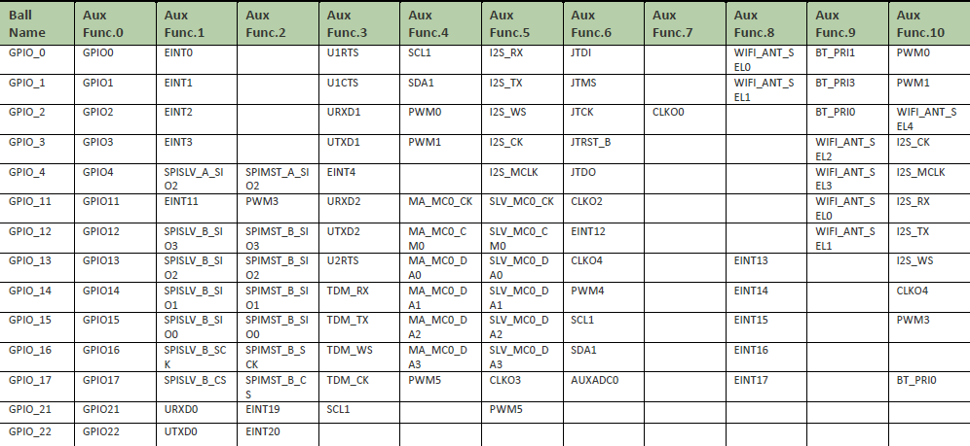

1. **WIFI ANT MATCHING**

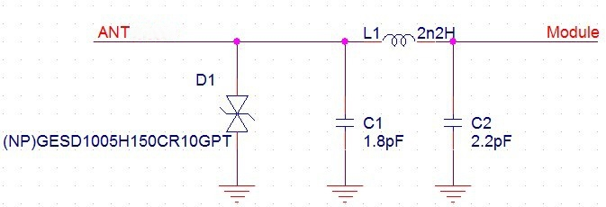

1. Reserve antenna matching circuits C1, C2 and L1 on the motherboard in advance，

specific values are adjusted according to actual tests.

1. Ensure the RF input on the motherboard has a 50 ohm impedance. It is not recommended to have a 90-degree route, cable length does not exceed 20 mm.
2. It is recommended to add a TVS tube at the end of the welding antenna to prevent ESD from damaging the WIFI module.
3. **Recommended Reflow Profile**

Referred to IPC/JEDEC standard. Peak Temperature : <250°C Number of Times : ≤ 2 times

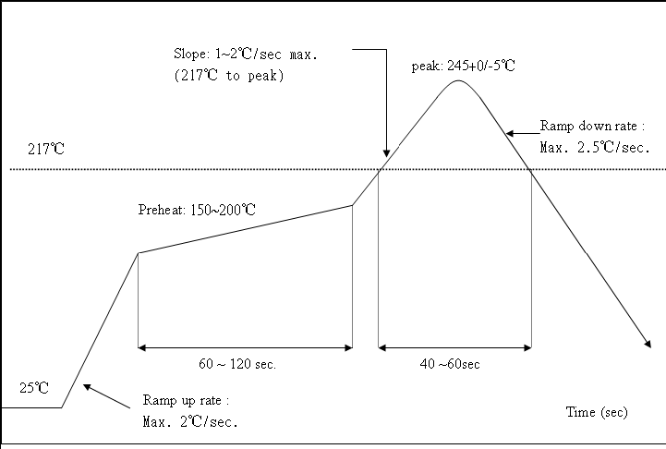

## Module Package

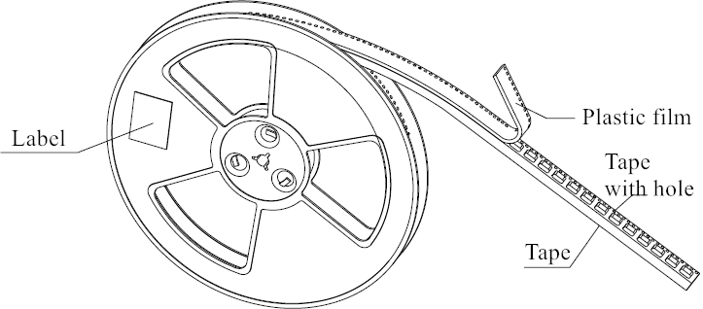

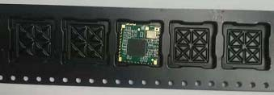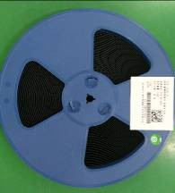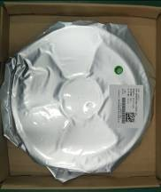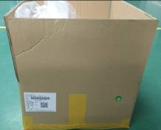



### Outer box :426*378*220mm

### Inner box：414*365*38mm

Anti-static vacuum bag：360X430mm

Package qty：7500PCS/carton (5 inner boxes, 1500PCS/inner box）

1. **Wireless module before the SMT note:**
2. When customers Open stencil must be sure the hole bigger to the Wireless module plate, please press 1 to 1 and 0.7 mm is widened to open outward, the thickness of 0.12 mm.
3. Can't get the wifi module bare hands when needs, must we wear the gloves and static ring. 3.The furnace temperature according to the size of the customer the mainboard ,generally like to stick on a tablet standard temperature of 250 +/- 5,can do 260+/- 5.

Storage and use Wifi module control should pay attention to the following matters:

* Module of the storage life of vacuum packaging：

1-1.Storage life:12 months. Storage conditions:<40℃. Relative humidity:<90%R.H.

1-2.After this bag is opened , devices that will be subjected to infrared reflow, vapor-phase reflow, or equivalent processing must be :

1-3.Check the humidity card :stored at≦ 20%RH.If :30%~40%(pink)or greater than 40%(red). Labeling module has moisture absorption.

① Mounted within 168 hours at factory conditions of: t≦ 30%℃，≦ 60%R.H.

② Once opened, the workshop the preservation of life for 168 hours. 1-4.If baking is required, devices may be baked for:

① Modules must be to remove module moisture problem.

② Baking temperature: 125 ℃, 8 hours.

③ After baking, put proper amount of desiccant to seal packages.

1-5. The actual number of module vacuum packing which is based on the actual number of packages to the customer requirements, vacuum packing of picture<1>

1. Module reel packaging items as follows.

2-1.Storage life:12 months. Storage conditions:<40℃. Relative humidity:<90%R.H.

2-2.Module apart packing after 168 hours，To launch patch need to bake, to remove the module hygroscopic, baking temperature conditions：125℃, 8hours.

2-3. The actual number of module reel packing which is based on the actual number of packages to the customer requirements, Reel packing of picture<2>

1. Module pallet packaging items as follows：

3-1.Storage life：3 months. Storage conditions:<40℃. Relative humidity:<90%R.H. 3-2.Module if not used within 48 hours, before launch the need for baking, baking temperature: 125 ℃, 8 hours.

3-3. Pallet packaging each plate is 100 PCS. The actual number of module pallet packing which is based on the actual number of packages to the customer requirements.